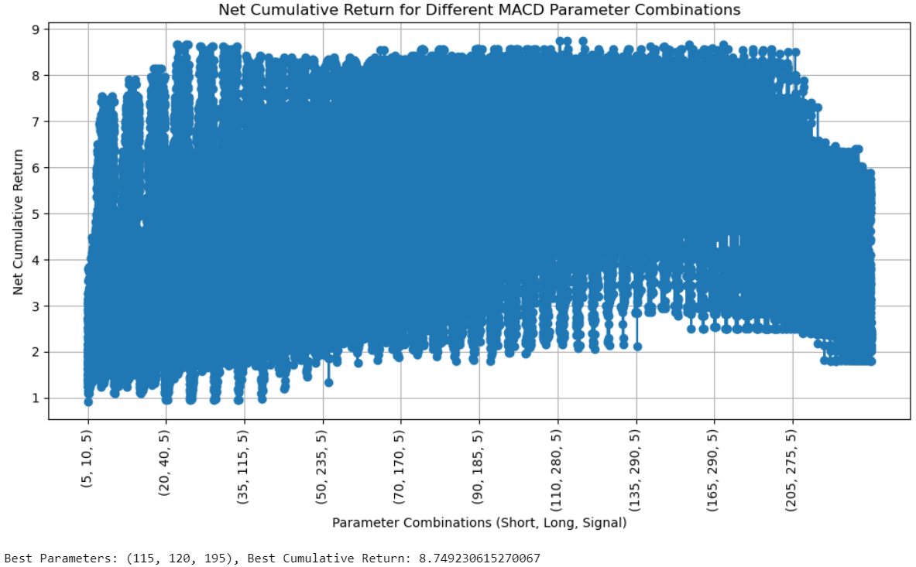

With optimal

Without optimal

